TTrace.Debug.Send('Left msg', 'Right msg');

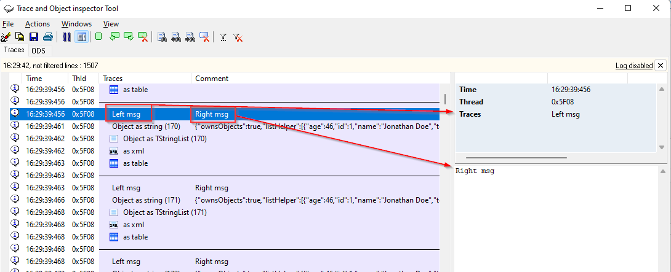

S := TJson.ObjectToJsonString(FList);  
TTrace.Debug.Send('Object as string (' + FList.Count.ToString + ')', S);

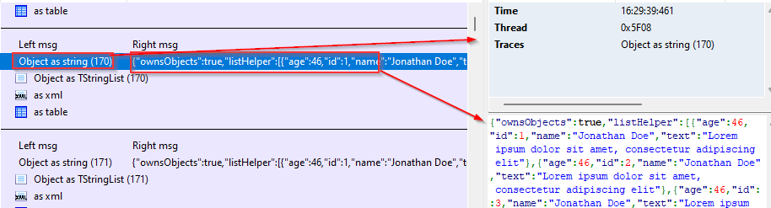

StrList.Text := FormatJson(s);  
TTrace.Debug.SendStrings('Object as TStringList (' +FList.Count.ToString + ')', StrList);

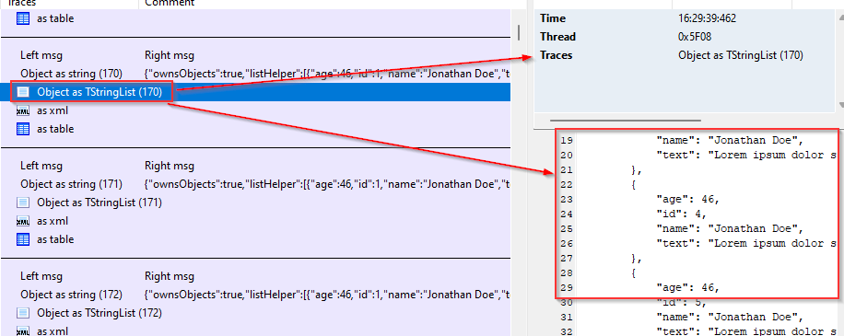

TTrace.Debug.SendXml('as xml', StrList.Text);

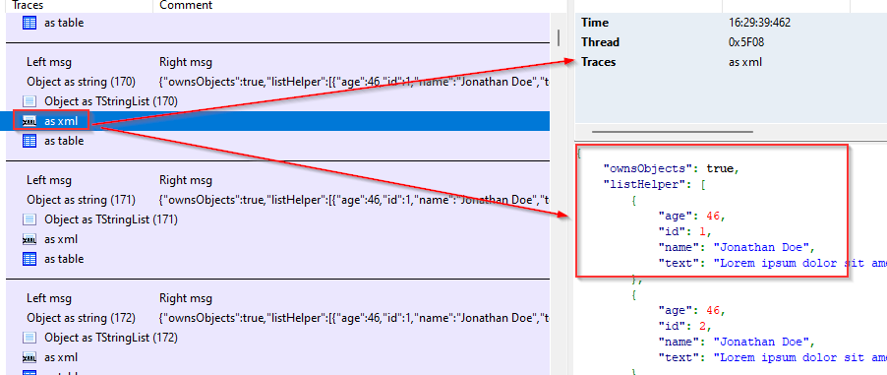

TTrace.Debug.SendTable('as table', StrList);

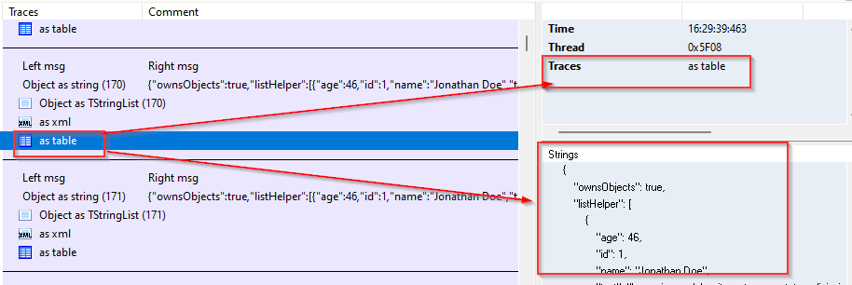

StrList := TStringList.Create;  
StrList.Add('one');  
StrList.Add('one');  
StrList.Add('one');  
StrList.Add('one');  
MainTrace.SendStrings('StrList', StrList);

